Methodology & Strategy Note: Carbon-Aware Compute Framework
European AI data centers are growing faster than the grid can decarbonize. Unlike fixed industrial loads, batch compute workloads can shift by hours, creating an untapped arbitrage between grid carbon intensity and operational scheduling. This note documents the methodology, findings, and limitations of a framework that quantifies that arbitrage across four European power markets.
1. Executive Summary:
Unlike traditional industrial loads, AI compute workloads (especially large-scale training and batch inference) possess inherent temporal flexibility. This framework quantifies the optimization problem across major European grids (France, Germany, Spain, and Italy; United Kingdom was excluded post-Brexit due to insufficient data coverage) through a dynamic capacity filter, allowing stakeholders to scale and assess data center flexible workloads instantly.
This analysis reveals a structural carbon intensity delta of 300–400 gCO2/kWh between optimal and worst-case country-hour blocks. By strategically shifting a 10MW flexible workload from peak fossil-fuel blocks to optimal clean blocks—specifically scheduling in France (00:00–04:00 UTC) instead of Italy (20:00–24:00 UTC) - an operator avoids 5,349 tonnes of CO2 per year. This carbon alpha is equivalent to removing approximately 2,139 passenger cars off the road annually, proving that data center flexibility can be converted directly into material, verifiable ESG impact.
2. Data Architecture & Governance
To ensure institutional-grade rigor, a dual-source data pipeline was constructed utilizing a highly normalized SQL schema designed for scalability and multi-country expansion.
2.1 SQL Schema Design Principles
- Country-Centric Design: Every table incorporates a country column from inception, transforming geographic expansion into simple INSERT operations rather than schema ALTER modifications.
- Temporal Standardization: All historical metrics are stored at hourly granularity using UTC primary keys to circumvent daylight saving time bugs across jurisdictions.
- Decoupled Emission Factors: IPCC lifecycle emission factors reside in a dedicated configuration lookup table, ensuring calculation logic remains untouched during regulatory updates.

2.2 Dual-Source Validation Framework
Carbon intensity figures are derived from primary ENTSO-E generation mix data using published IPCC lifecycle emission factors median values (Gas: ~490, Coal: ~820, Nuclear: ~12, Wind: ~11, Solar: ~45 gCO2/kWh). To validate these calculations, a 90-day validation layer was ingested via the Electricity Maps API. A Mean Absolute Error (MAE) check was executed across overlapping windows:
Derived Intensity = Sum(MW_by_Source * IPCC_Factor) / Total_MW
Validation Metric: MAE = Average(|Derived_Intensity - Electricity_Maps_Value|)
Country | Matched Hours | MAE | Correlation | Mean Bias
DE_LU | 2160 | 109.64 | 0.9424 | -109.5
ES | 2160 | 8.56 | 0.9759 | 7.58
FR | 2160 | 5.70 | 0.9662 | 5.69
IT | 2160 | 48.49 | 0.9628 | 42.19

Divergence is expected due to two methodological differences in Electricity Maps from this analysis:
- Consumption-based vs Production-based: EM applies a flow-tracing algorithm that attributes imported electricity to the consuming country. This analysis uses production-based intensity (ENTSO-E domestic generation mix only). Net-importing countries (IT) show derived > EM because low-carbon imports (FR nuclear, CH hydro) are visible to EM but not to our calculation.
- Grid-specific vs IPCC generic emission factors: In Europe, EM derives emission factors from EU-ETS reported plant-level emissions divided by ENTSO-E generation, updated annually. This captures country-specific fuel characteristics that IPCC AR5 generic medians do not. Notably, Germany's high lignite share, where actual plant emissions (~900–1200 gCO2/kWh) exceed the IPCC coal median (820 gCO2/kWh) used here. This causes derived < EM for DE_LU.

The MAE for FR and ES (5.70 and 8.56 gCO₂/kWh respectively) confirms the methodology is sound for low-fossil grids. DE_LU's elevated MAE (109.64) is structurally explained by lignite-specific emission factors, not data error. The high correlation across all four countries (r > 0.94) confirms the derived series captures the correct directional signal for dispatch ranking purposes.
  - Data Scope Notes
GB data was excluded from the primary analysis. Post-Brexit, GB operates under a separate market structure (N2EX/Elexon) rather than ENTSO-E's standard reporting format. ENTSO-E data coverage for GB is available but exhibits higher reporting latency and source-type aggregation inconsistencies relative to the four continental markets. A two-country FR vs GB extension is feasible but out of scope for this version.
3. Strategic Recommendations & 4-Hour Block Ranking Analysis
Aggregating hourly data into realistic 4-hour compute windows yields definitive operational dispatch strategies:
Rank | Country Code | Time Block (UTC) | Grid Profile & Operational Character | Strategic Action
Tier 1 | FR | 00:00–04:00 | Nuclear Baseload (70-80% nuclear). Near-zero carbon floor. Flat profile across seasons. | Primary Anchor: Schedule highest-intensity batch training here.
Tier 2 | ES | 10:00–14:00 | Solar-Dominant. Strong intraday "solar trough" in Q2/Q3. | Tactical Shifting: Utilize during peak summer daylight hours.
Tier 3 | DE | 16:00–20:00 | Wind-Heavy but Intermittent. Supported by heavy coal/gas backup during evening demand peaks. | Avoidance Block: High risk of carbon spikes; high value-adds for introducing forecasting systems.
Tier 4 | IT | 20:00–24:00 | Gas-Dependent. Highest baseline emissions with pronounced evening gas-peaker spikes. | Critical Avoidance: Strict block to minimize Scope 2 exposure.

- The France Baseload Bench: France provides the absolute carbon floor due to its stable nuclear infrastructure. Seasonal variations are minimal, making it the default baseline for flexible operations.
- The Spain Solar Trough: Spain exhibits a classic intraday duck curve. During Q2 and Q3 midday blocks, its carbon intensity plummets, making it a highly competitive spatial alternative to France.
- The Germany/Italy Risk Profiles: Germany possesses massive wind capacity but displays severe swings (300+ gCO2/kWh delta) when wind drops and fossil backups engage. Italy represents the highest emissions baseline due to its structural reliance on natural gas peakers.
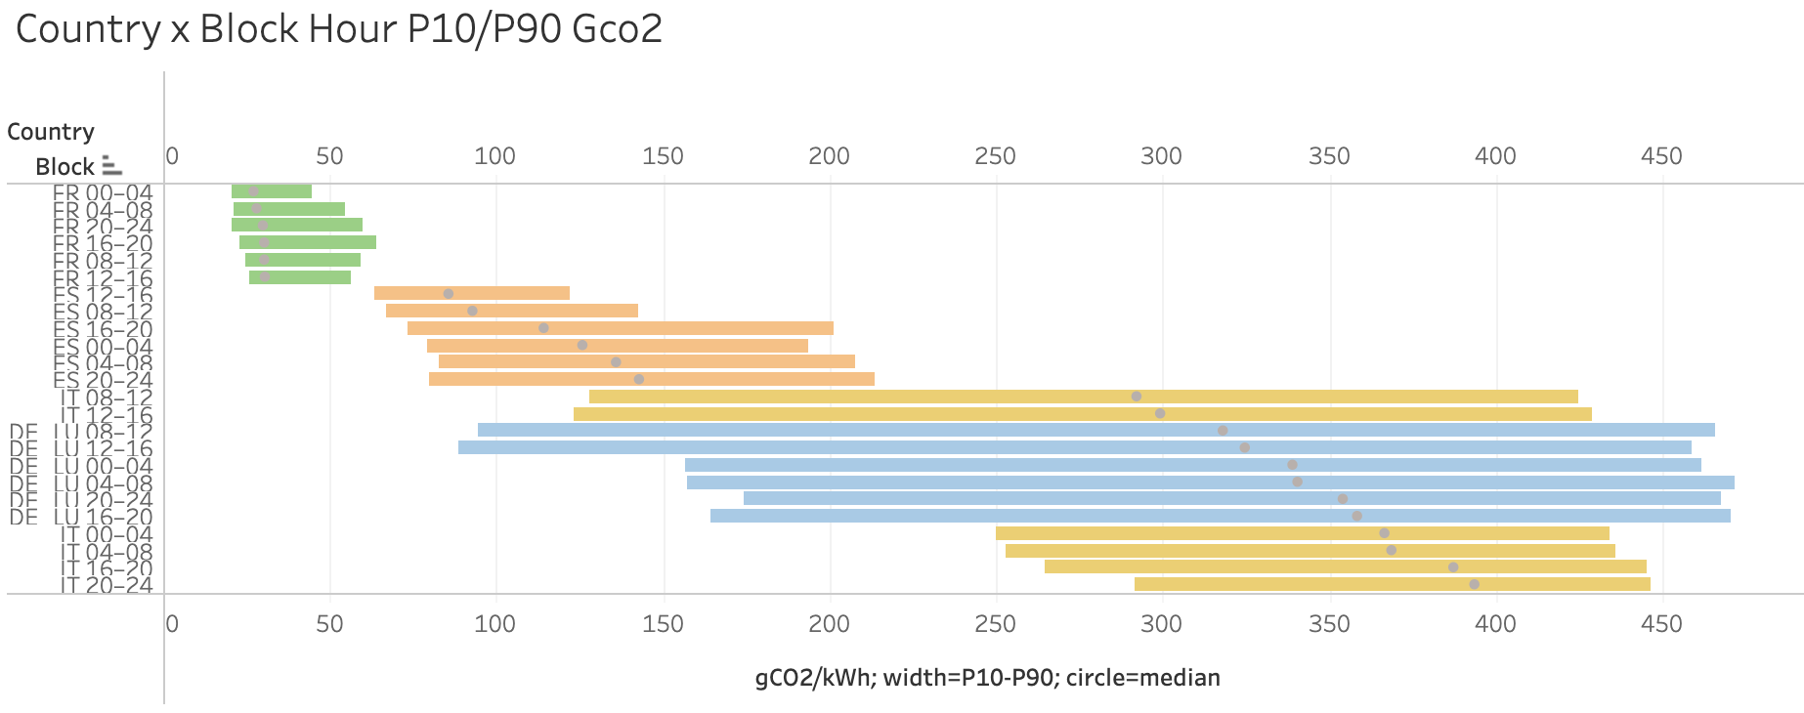

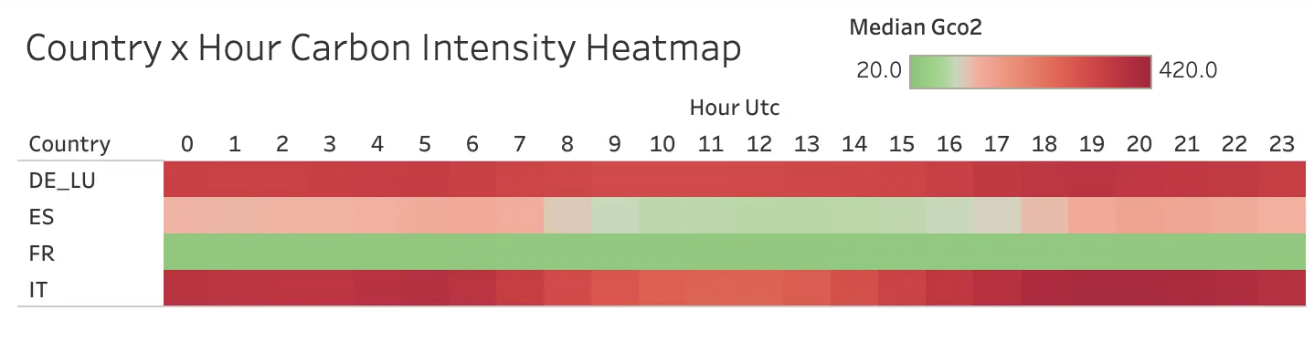
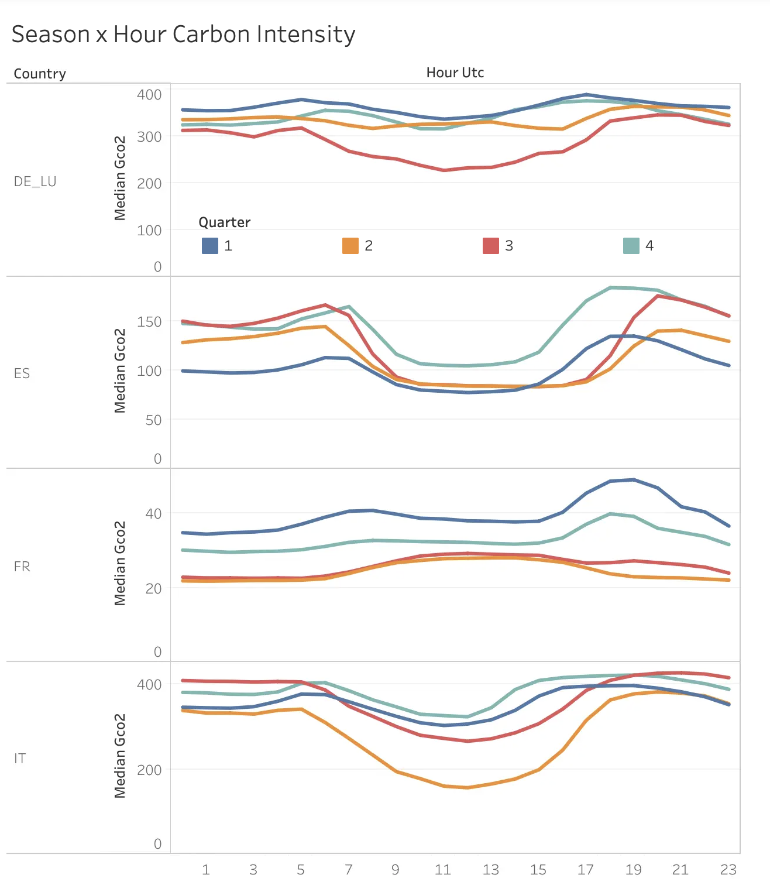
4. Honest Limitations & Boundary Conditions
1. Maximum Theoretical Alpha vs. Operational Realities: The current optimization framework evaluates historical country-block extremes (e.g., France 00-04 vs. Italy 20-24) to establish a “Maximum Theoretical Alpha” and quantify the aggregate size of the optimization prize. In reality, data centers are bound by operational constraints such as minimum uptime guarantees, base-load constraints, and service level agreements (SLAs). It is a directional probability guide rather than a deterministic real-time execution model.
2. Historical Medians vs. Real-Time Execution: The ranking framework relies on historical medians to map long-term structural grid profiles and seasonal patterns. While highly descriptive for corporate strategic planning, historical medians cannot predict or respond to real-time grid volatility, sudden localized weather drops affecting wind/solar yields, or unexpected grid congestion events.
3.. Omission of Physical Network and Regulatory Constraints: The framework assumes perfect workload mobility and omits physical network latency, cross-border interconnector caps, and data residency regulatory frameworks (such as GDPR).
4. IPCC Lifecycle vs. Marginal Emission Factors: This framework utilizes IPCC lifecycle emission factors (accounting for supply chains), which are ideal for Scope 2 carbon accounting. However, they do not reflect marginal emission factors (the carbon cost of the next incremental unit of grid load triggered by an active data center). While marginal modeling is more behaviorally precise for dispatching, lifecycle factors provide the foundational tracking layer required by modern ESG rating methodologies.
5. Methodological Variance (Generation vs. Consumption): Emission calculations are generation-based to ensure data consistency across ENTSO-E nodes. However, data validation reveals a consistently positive Mean Absolute Error (MAE) for heavy net-importing grids like Italy during specific seasonal blocks by up to 175 gCO2/kWh (a ~46% variance against a 380gCO2/kWh baseline). This positive error stems from omitting cross-border alpine transits. In reality, low-carbon French nuclear and Alpine hydro physically blend into the Italian grid, diluting local natural gas peaker intensity. Consequently, while Italy’s “Critical Avoidance” status remains directionally accurate, related absolute carbon-saving figures represent upper bounds.

